ADVENTURE WORKS · TECHNICAL SUPPORT

Chain Skipping or Slipping Under Load
Drivetrain Document TS-003 Rev. A
Applies to | All geared Adventure Works models
Difficulty | Intermediate
Time required | 20 – 45 minutes
Tools needed | Chain wear gauge, Chain tool, Hex keys, Cassette lockring tool & chain whip

Symptoms
- The chain jumps or 'ghost-shifts' when you pedal hard, especially uphill.
- A rhythmic clunk once per pedal stroke in certain gears.
- Skipping is worse in the most-used gears (middle of the cassette).
- Shifting that was once crisp has become vague.
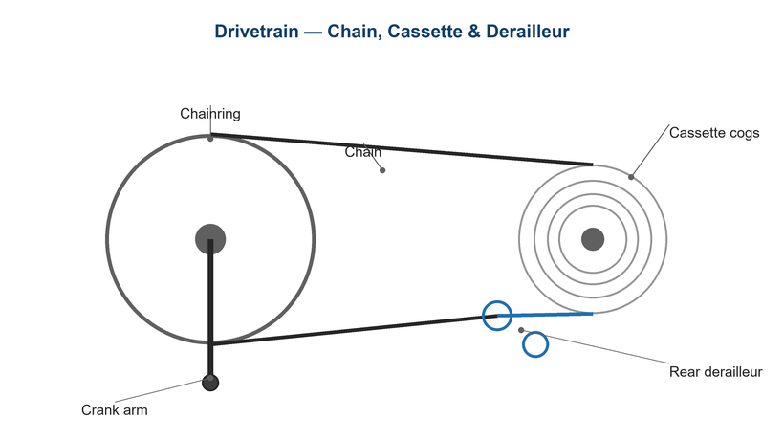
Figure 1. Chain, cassette, and rear derailleur must work together for clean power transfer.

Likely Causes
- A worn chain that has 'stretched' past 0.5–0.75% elongation.
- Worn cassette cogs that no longer mesh with a new chain.
- Cable tension drift causing the chain to ride between cogs.
- A stiff or seized chain link from rust or a previous repair.
- Bent derailleur hanger throwing off indexing.
Safety first
- Keep fingers clear of the chain and chainring — a chain under load can pinch hard.
- Work with the bike securely supported in a stand or stable on its wheels.
- Degreasers and lubricants can make floors slippery; clean up spills immediately.

Customer Fix — Step by Step
Suitable for home repair with basic tools. Work through the steps in order.
- Shift through every gear while pedaling lightly and note which gears skip.
- Check the chain with a wear gauge. If a 0.5% gauge drops fully into the chain, the chain is worn and should be replaced.
- Inspect for a stiff link: back-pedal slowly and watch for a link that hops as it passes the derailleur; flex it side-to-side to free it.
- Fine-tune cable tension with the rear barrel adjuster — a quarter turn at a time — until the chain runs quietly in each gear.
- Clean and re-lubricate the chain, then wipe off excess lube.
- Re-test under load by pedaling firmly while seated. If skipping continues, the cassette is likely worn (technician step).

Technician Reference
Additional checks and adjustments for service technicians and advanced users.
- Measure chain elongation precisely; replace at 0.5% (11/12-speed) or 0.75% (≤10-speed).
- If the chain was ridden well past the wear limit, replace the cassette together with the chain — a new chain on a worn cassette will keep skipping.
- Check derailleur hanger alignment with a gauge; straighten or replace if bent.
- Verify B-tension so the upper jockey wheel clears the largest cog by 5–6 mm.
- Set the high/low limit screws, then index the shifting from the smallest cog outward.
- Confirm the chain is the correct length: in the big-big combination the derailleur cage should hang just short of horizontal.

Torque & Specifications
Fastener / setting | Specification
Chain replacement limit | 0.5% (11/12-spd), 0.75% (≤10-spd)
Cassette lockring | 40 N·m
Derailleur hanger bolt | 5 – 6 N·m
Jockey-to-cog gap (B-screw) | 5 – 6 mm
Rear derailleur mount bolt | 8 – 10 N·m

Figure 2. A worn chain rounds the cogs; replace both if elongation is severe.
Pro tips
- Replace the chain before it reaches 0.5% wear to make the cassette last far longer.
- Number your chain quick-link orientation so reinstalls are consistent.

When to Visit a Service Center
- Skipping continues after fitting a new chain and cassette.
- The derailleur hanger is bent and you lack an alignment gauge.
- Shifting is erratic across all gears (possible worn shifter or frayed cable).
- There is play or roughness in the freehub body.
This guide is provided for reference. Torque values are typical starting points — always follow the specific component manufacturer's instructions. © Adventure Works.

